 

INSTITUTE FOR ADVANCED COMPUTING AND SOFTWARE DEVdsELOPMENT AKURDI, PUNE

Documentation On

**“REVV-N-RIDE**

**-Car Rental app”**

PG-DAC Sept 2021

*Submitted By:*

**Group No:**

Mr. Rutvik Gulhane Roll No. 9075 Mr. Tejas Ghag Roll No. 9106

**Rohit Puranik Mr. Geeta Darunte**

**Centre Coordinator Project Guide**

**Table of Contents**

1. Introduction 1

Document Purpose 2

Problem Statement 2

Product Scope 2

Aim & Objectives 2

1. Overall Description 3

Product Perspective 3

Benefits of Revv-N-Ride System 3

User and Characteristics 3

Operating Environment 3

Design and Implementation Constraints 3

1. Requirements Specification 4

External Interface Requirements 4

3.3 Non-Functional Requirements 12

1. System Diagram 11

Activity Diagram 11

Data Flow Diagram 13

Class Diagram 15

Use Case Diagram 16

ER Diagram 16

1. Table Structure 17
2. Conclusion 19

Future Scope 19

1. References 20

**List of Figures**

Figure 1 Admin Activity Diagram 11

Figure 2 user Activity Diagram 12

Figure 4 Level 0 Data Flow Diagram 13

Figure 8 Class Diagram 15

Figure 9 Use Case Diagram 16

Figure 10 ER Diagram 16

# Introduction

This document is meant to delineate the features of Revv-N-Ride, so as to serve as a guide to the developers on one hand and a software validation document for the prospective client on the other. Revv-N-Ride is designed to provide easy vehicle and transport access to customers. This software helps all those who are in a hunt for a vehicle for their next vacation or even for a simple commute. The admin has rights to add new vehicles to the inventory or delete old non-functional vehicles from the website. Users can browse through various vehicle options available through a range of options and register themselves on the website to book a vehicle. Revv-N-Ride is a one stop solution to civilians who don’t have access to a personal vehicle or even someone who wants to get a firsthand experience of luxury rides. The keeps track of the vehicles added by the customer to their wish list and customer can check out with the selected vehicle. .

## Document Purpose

The advancement in Information Technology and internet penetration has greatly enhanced various business processes and communication between car owners and other car enthusiasts who are looking for a vehicle to rent. This Car rental system is developed to provide the following services:

Enhance Business Processes:

To be able to use internet technology to project to the global world instead of limiting their services to their local domain alone, thus increase their return on investment (ROI).

Online Rental Management:

A tool through which admin can register a vehicle and customers on the website and provide many functionalities to them. The admin also receives some set of functionalities which help in managing the website.

Quick checkout:

This system’s key functionality is that it helps in quickly browsing through vehicle

## Problem Statement

Current scenario in the car renting business is such that a person looking to rent a car for their vacation either have to go through various travel agencies that have high commission rates and are very costly and have a selective number of vehicle options available. Customers eventually have to settle for less as they don’t find the perfect suited vehicle for their needs, and yet have to shell out a good sum of money. Revv-N-Ride solves these kind of problems with its wide range of options and minimal renting costs.

## Product Scope

This project traverses a lot of areas ranging from business concept to computing field, and required to perform several researches to be able to achieve the project objectives. The area covers include:

* Timely updation of inventory ensures all vehicles available to the users are in mint condition.
* J2EE Technology used for the development of the application.
* Admin and Customers will be able to us the system effectively and efficient management of admin rights ensures best service to the users.
* Web-platform means that the system will be available for access 24/7 except when there is a temporary server issue which is expected to be minimal.

**Aims & Objectives**

Specific goals are: -

* To produce a web-based system that allow the admin to add available cars to rent and provide wide range of options to users such that they don’t have to bother about looking elsewhere .
* To ease car owners by providing them a source of income for their vehicles which are seldom used.

# Overall Description

## Product Perspective:

2.1.1 Existing system function:

Current scenario in the car renting business is such that a person looking to rent a car for their vacation either have to go through various travel agencies that have high commission rates and are very costly and have a selective number of vehicle options available. Customers eventually have to settle for less as they don’t find the perfect suited vehicle for their needs, and yet have to shell out a good sum of money. Revv-N-Ride solves these kind of problems with its wide range of options and minimal renting costs, all these at the ease of sitting at your home and browsing through our website.

* **III. PROPOSED SYSTEM**

**Product functionality:**

Revv-N-Ride provides the features for admin and user. It includes several functionalities describes as below:

*Vehicle inventory Management:*

It provides facility to add, update, delete and view the available to be rented. We can view their details and also update it if that particular vehicle is no longer in use or under maintenance.

*Registering user:*

People new to the service can register themselves for the first time as a user after which they can login with their authentication.

*Booking vehicle:*

Users after they have successfully registered themselves on the website can browse through the vehicle options available and fill a form to book the vehicle of their choice in their city.

*Profile updation:*

Registered users can update their own profile according to changes in their details like contact no, or city in which they reside.

## Benefits of Revv-N-Ride

* This online car rental solution is fully functional and flexible.
* It is very easy to use.
* Convenience: Revv-N-Ride allows you to book a car from the comfort of your own home, office or anywhere you may be, without having to physically visit a rental agency.
* Time-saving: By using Revv-N-Ride, you can save time by skipping the long queues at rental agencies, paperwork, and negotiations.
* Cost-effective: Revv-N-Ride offers competitive pricing and discounts, allowing you to save money on your car rental.
* Wide range of choices Revv-N-Ride offers a wide variety of vehicles to choose from, including different models, sizes, and features to meet your specific needs.
* 24/7 availability: Revv-N-Ride offers 24/7 availability, allowing you to rent a car at any time of the day or night.

**Users and Characteristic****s:**

*Admin*:

* + Admin can login to the system.
  + Add a car to system.
  + Delete a car from the system.
  + Add car details.
  + View available cars.
  + Update car details.

*User:*

* + User can login to the system.
  + User can register themselves on the website as customer with a simple form.
  + User can browse through the vehicles available to be rented at the moment.
  + User can add a vehicle of their choice to their cart and confirm the booking.

## Operating Environment:

Server Side:

**Processor:** Intel® Xeon® processor 3500 series

**HDD:** Minimum 500GB Disk Space

**RAM:** Minimum 4GB **OS:** Windows 10, Linux 6 **Database:** Mysql

Client Side (minimum requirement):

**Processor:** Intel Dual Core

**HDD:** Minimum 80GB Disk Space

**RAM:** Minimum 1GB

**OS:** Windows 8 and above, Linux

## Design and Implementation Constraints:

* + The application will use J2EE, React, Bootstrap, JavaScript, and CSS as main web technologies.
  + HTTP and FTP protocols are used as communication protocols. FTP is used to upload the web application in live domain and the client can access it via HTTP protocol.
  + Several types of validations make this web application a secured one.
  + Since Revv-N-Ride is a web-based application, internet connection must be established.
  + The Revv-N-Ride will be used on PCs and will function via internet or intranet in any web browser.
  1. **Specific Requirement**

## External Interface Requirements:

User Interfaces:

* + - All the users will see the same page when they enter in this website. The homepage shows advertisements and the user has to click on the ‘login’ tab to login on the site, if not a registered user, then user gets an option to signup. After signing up user can login. This page asks the users a username and a password.
    - After being authenticated by correct username and password, user will be redirect to their corresponding profile where they can do various activities.
    - The user interface will be simple and consistent, using terminology commonly understood by intended users of the system. The system will have simple interface, consistence with standard interface, to eliminate need for user training of infrequent users.

Hardware Interfaces:

* + - No extra hardware interfaces are needed.
    - The system will use the standard hardware and data communication resources.
    - This includes, but not limited to, general network connection at the server/hosting site, network server and network management tools.

Application Interfaces:

**OS:** Windows 10, Linux

**Web Browser:**

The system is a web-based application; clients need a modern web browser such as Mozilla Firebox, Internet Explorer, Opera, and Chrome. The computer must have an Internet connection in order to be able to access the system.

Communications Interfaces:

* + - This system uses communication resources which includes but not limited to, HTTP protocol for communication with the web browser and web server and TCP/IP network protocol with HTTP protocol.
    - This application will communicate with the database that holds all the booking information. Users can contact with server side through HTTP protocol by means of a function that is called HTTP Service. This function allows the application to use the data retrieved by server to fulfil the request fired by the user.
  1. **System Design**

## Activity Diagram

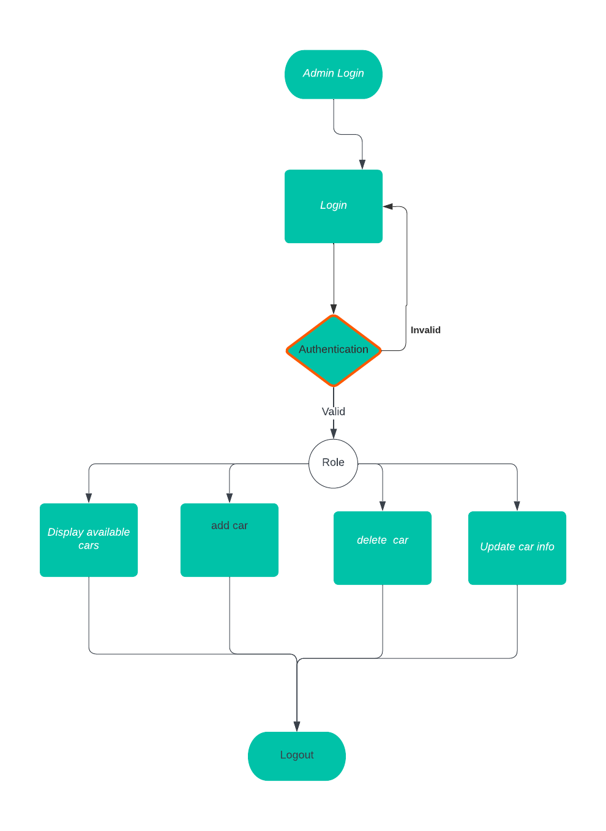

**Figure 1: Admin Activity Diagram**

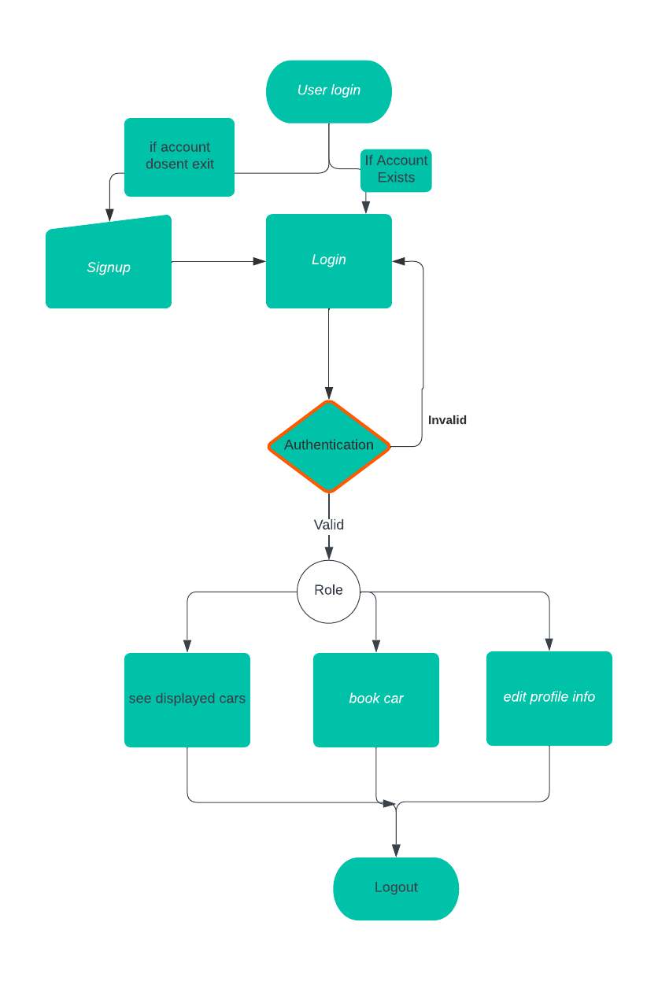

**Figure 2: User Activity Diagram**

## Data Flow Diagram

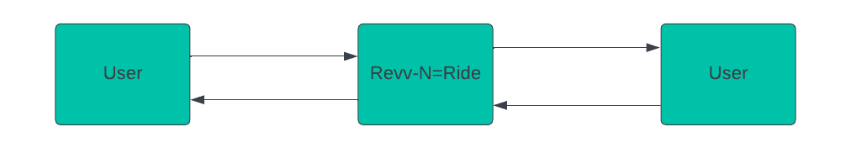

**Figure 4: Level 0 Data Flow Diagram**

## Class Diagram

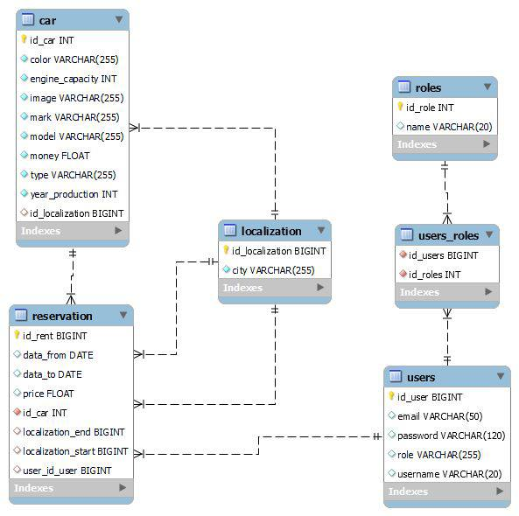

**Figure 8: Class Diagram**

## Use Case Diagram

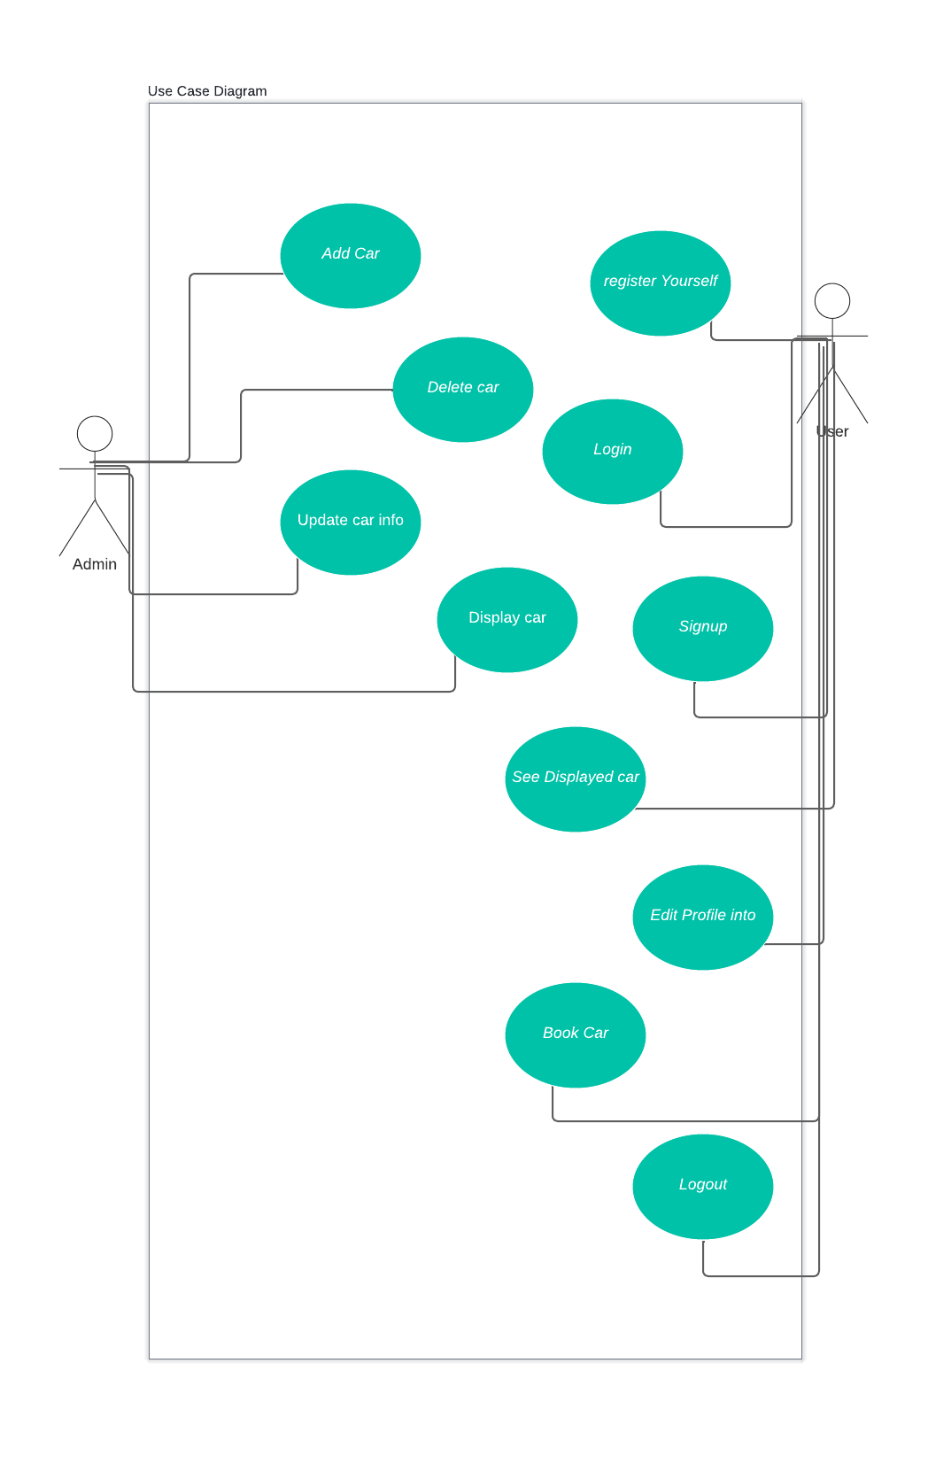

**Figure 9: Use Case Diagram**

## ER Diagram:



**Figure 10: ER Diagram**

# Table Structure

**Car :**

|  |  |  |
| --- | --- | --- |
| **Name** | **Type** | **Extra** |
| Id_car | int | Primary & Auto-increments |
| color | Varchar |  |
| Engine_capacity | Int |  |
| Image | Varchar |  |
| Mark | Varchar |  |
| Model | Varchar |  |
| Money | Float |  |
| Type | Varchar |  |
| Year_production | Int |  |
| Id_localization | Bigint |  |
|  |  |  |

**Reservation:**

|  |  |  |
| --- | --- | --- |
| **Name** | **Type** | **Extra** |
| Id_rent | **Bignit** |  |
| **Date_from** | **Date** |  |
| **Date_to** | **Date** |  |
| **Price** | **Float** |  |
| **Id_car** | **Int** |  |
| **Localization_end** | **Bigint** |  |
| **Localization_start** | **Bigint** |  |
| **User_id** | **bigint** |  |
|  |  |  |

**localization:**

|  |  |  |
| --- | --- | --- |
| **Name** | **Type** | **Extra** |
| Id_localization | bigint |  |
| City | Varchar |  |
|  |  |  |

**Roles:**

|  |  |  |
| --- | --- | --- |
| **Name** | **Type** | **Extra** |
| Id_role | int |  |
| name | varchar |  |
|  |  |  |

**Users_roles:**

|  |  |  |  |
| --- | --- | --- | --- |
|  | **Name** | **Type** | **Extra** |
| Id_users | Bigint |  |
| Id_roles | Int |  |
|  |  |  |
|
|
|
|

**Users:**

|  |  |  |
| --- | --- | --- |
| **Name** | **Type** | **Extra** |
| Id_user | Bigint |  |
| Email | Varchar |  |
| Password | Varchar |  |
| Role | Varchar |  |
| Username | varchar |  |
|  |  |  |

# Conclusion

Revv-N-Ride app is a mobile application designed to help users rent cars for short-term periods. The app allows users to search for available cars, choose a pickup and drop-off location, and reserve the vehicle for a specific period of time. It typically offer a variety of car types, from compact cars to luxury vehicles, etc..

Users typically need to create an account, provide personal information and agree to the rental terms and conditions.

Revv-N-Ride app can be a convenient alternative to traditional car rental services, allowing users to quickly and easily rent a car from their mobile device. They are particularly useful for travelers or people who need temporary transportation for short periods of time, and can save users time and money compared to traditional car rental service

**Future Scope**

This project can be enhanced further by adding functionality for car owners to register their cars for renting on the website. The software is flexible enough to be modified and implemented as per future requirements. We have tried our best to present this free and user–friendly website to car enthusiasts and travelers. Message and Email alerts for various happenings in the society can be added to the system so that users do not miss the updates and happenings of the society.